Dean Gladish

March 5, 2018

A New Installation for Schäufelein’s Roundel Set of Five

Hans Schäufelein (“Little Shovel”) was a talented German artist who produced the Roundel Set now on display in Room G341 of the MIA museum. By the time Schäufelein produced this set, which consists of five circular stained-glass windows depicting the life of Jesus Christ[1], he had already worked extensively in the workshop of Albrecht Dürer. Although little remains known of his early life, Hans Schäufelein became a prominent figure who was even commissioned by the Holy Roman Emperor Maximilian I to make wood blocks due to his skill in craftsmanship[2]. The stained-glass panel that I choose depicts the Resurrection, the Day of Judgment, the Adoration of the Magi, and the Nativity – all exemplary artifacts of the innovative Renaissance style of Southern Germany and Switzerland that combine traditional Gothic and Catholic knowledge with the ideals of the Reformation[3]. I choose this work of art to be moved to a devotional setting – a small chapel – for several reasons that honor the wishes of the artist. I believe that Schäufelein would have liked to implement the Roundels in a natural setting, use them as a symbol of the Reformation, and include them as part of a personalized place of worship[4].

In my opinion, the current location of the Roundel set in the museum does not do it justice; it figures less as a symbol of the Counter-Reformation and more as a personalized piece of artwork meant for a smaller devotional church in a medieval town[5]. The artwork completely lacks the sense of egoism and contemporary life that pervades the surrounding works of emotionally charged, pre-Baroque era artwork. I believe that Schäufelein created this Roundel set as a personal meditation on the idyllic life of Christ and the unique style of Dürer[6].

I choose to relocate Schäufelein’s Roundel set from its current location – the area between Dramatic Theatre and the Counter-Reformation – into a family chapel, made mostly of concrete and located in Nuremberg, that exhibits Gothic and High Renaissance characteristics[7]. In my proposal the set itself is located within a stained-glass window above an altarpiece depicting the crucifixion of Jesus Christ on a wooden cross. Within this symmetrical room there are eight such stained-glass window panels depicting angels. Beneath each window exist devotional paintings by artists whom Schäufelein would have known at the time – among these are *The Nymph of the Spring* and *The Crucifixion with the Converted Centurion* by Lucas Cranach the Elder[8]. In this way I maintain his original intent and historical background[9].

In addition to this I would like to include a large Altarpiece in the center of this room of worship. It demonstrates scenes of Hans’ Passion and the Apocalypse in the format of a three-paneled triptych. The roof of the chapel itself contains a mural directing the viewer toward heaven per Renaissance style. Its style of brushwork should be soft and flowing in order to convey the thoughtful and gentle character of Schäufelein and his contemporaries Jörg Breu and Lucas Cranach[10]. Furthermore, I would like to add Dürer as a co-author in an inscription that dedicates the chapel not only to Schäufelein but to his mentor. Thus, my environment demonstrates not only the work of the artist but of all major influences on him as well[11]. Adding Dürer as a co-author allows me to resolve some ambiguity regarding the problem of creation – his workshop was indubitably one of great collaboration.

To indicate Schäufelein’s strict attention to detail I include his signature, a shovel and a capital H, above the head of the central Magi in his masterpiece. The interior of the chapel will be defined by a vaulted and pointed roof and the exterior will be laden with spires that conform to the exigencies of structural balancing[12]. Behind this main room which contains the sacrificial altar I construct a long passageway that leads to the chapel’s entrance. Behind three large stone pillars on each side that define a central arch, I include works of art by Schäufelein – the Siege of Bethulia, Judith and Holophernes, and Crucifixion with John the Baptist and King David[13]– with neatly inscribed annotations describing their relevance to medieval history and warfare. Around the top of each pillar I include putto sculptures in white marble[14]. At the end of this passageway the door that leads to the outside world will exhibit the self-portrait of the High Renaissance master Albrecht Dürer.

The very top of the chapel is defined by a dome in the style of Albrecht Dürer’s famous propagandist woodblock print, *The Triumphal Arch of Maximilian I[15]*. The reason for this is that it actualizes the beautiful work envisioned by Dürer and would be instantly recognizable by those acquainted with the history of art. Such an arrangement also expresses the fact that it was Maximilian I who influenced much of High Renaissance art through his commissions, among which include the intricate sketches of Schäufelein. Technical details aside, my proposal allows for the Roundel set to be exhibited in a setting that properly tells the story of Jesus Christ from Crucifixion to Resurrection. The central and only room in the chapel serves a great function by directing the viewer’s eyes first toward the stained-glass. The dim sunlight drawn through the glass brings the viewer away from interactions of daily life toward the purity of heaven and a higher moral truth.

Facing toward the rising sun, the set exhibits its maximum awe-inspiring effect during the morning when people are most likely to engage in prayer. Altogether my exhibition honors the legacy of Maximilian I as a dedicated patron of stained glass[16]. The technique used to manufacture smaller panels derives from that used for larger church windows – thus, I believe that my exhibition is quite fitting. Furthermore, the implementation of natural sunlight reveals the dynamic effect of scratch stippling. I argue that no amount of artificial lighting can reproduce the three-dimensional luminosity, changing shape and color, and subtle gradations of technique that are revealed quite easily by natural light[17]. It is for these reasons that I have made this proposal to represent Schäufelein’s work as he intended.

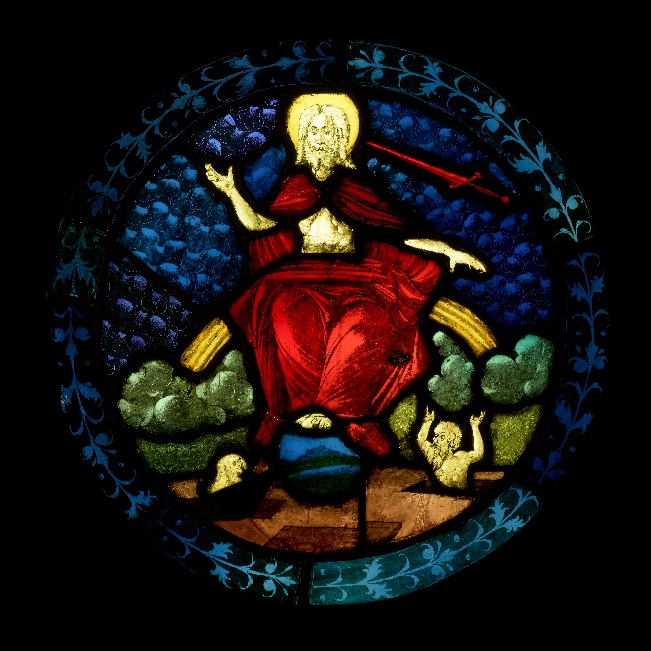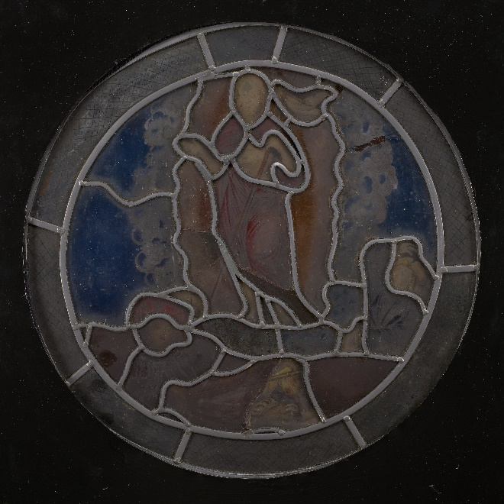

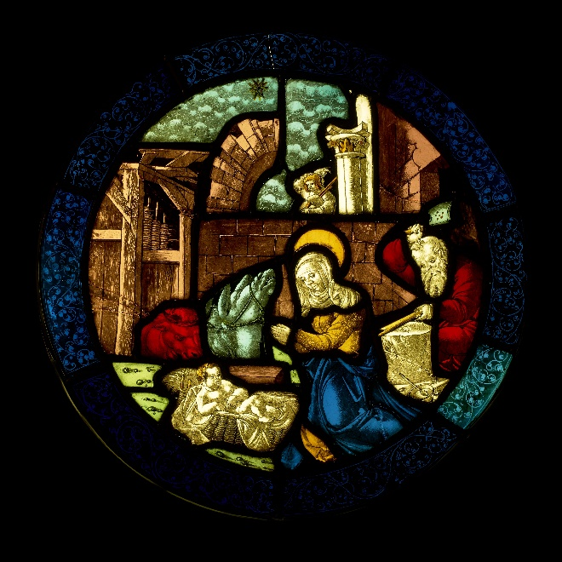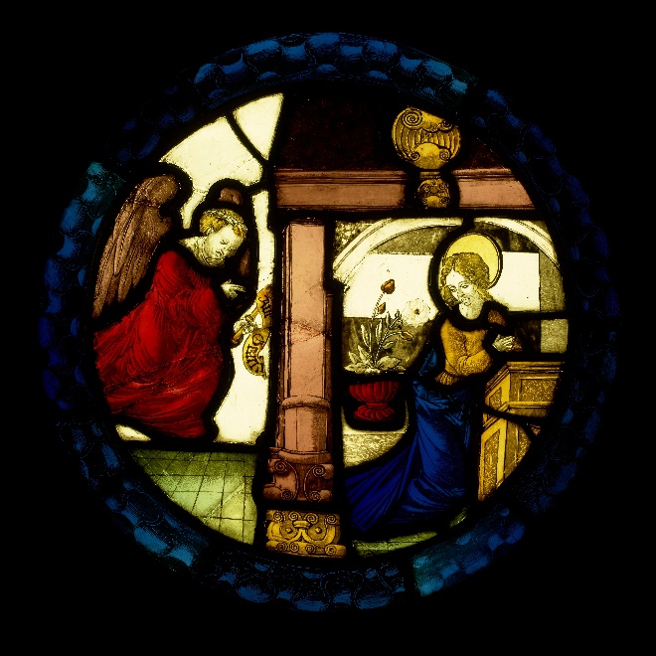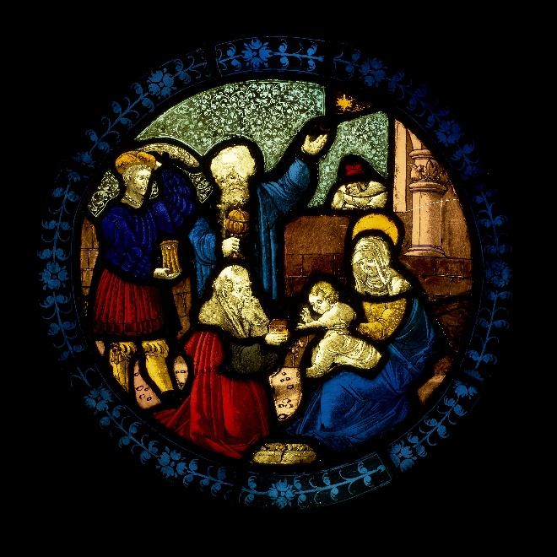

Hans Schäufelein, *Roundel Set*, ca. 1510. Stained glass and lead (48.9 x 48.9 x 0.64 cm each). Donated by the Walter C. and Mary C. Briggs Trust Fund in 2014.

**References:**

Butts, Barbara, and Lee Hendrix.  *Painting on Light: Drawings and Stained Glass in the Age of Dürer and Holbein*. Los Angeles, California: Getty Publications, 2001.

Conway, William Martin, Sir. "The Age of Albrecht Dürer." In *Literary Remains of Albrecht Dürer*, 1-14. Princeton University: University Press, 1889.

Dürer, Albrecht. “Ehrenpforte (The Triumphal Arch of Maximilian I), 1515 (printed 1799).” Collection | Minneapolis Institute of Art | The Driscoll Art Accessions Endowment Fund. https://collections.artsmia.org/art/116298/ehrenpforte-albrecht-duerer.

Getty, J. Paul. "Hans Schäufelein (Getty Museum)." Paul Getty Museum | The Getty. The J. Paul Getty Trust. January 29, 2018.

http://www.getty.edu/art/collection/artists/508/hans-schufelein-german-14801485-1540/.

Hand, John Oliver. *German Paintings of the Fifteenth through Seventeenth Centuries*. Edited by Sally E. Mansfield. National Gallery of Art, Washington: Cambridge University Press. The Collections of the National Gallery of Art Systemic Catalogue.

McCollum, Christina. "Northern Renaissance Art (1400–1600)." Art History Teaching Resources. January 16, 2016.

http://arthistoryteachingresources.org/lessons/northern-renaissance-art/.

Schäufelein, Hans Leonhard. "G341: Up Close and Personal | MIA." Collection | Minneapolis Institute of Art | Mia.

https://collections.artsmia.org/galleries/341.

Stokstad, Marilyn, and Michael W. Cothren. *Art History*. 6th ed. Vol. 2. Upper Saddle River, NJ: Pearson, 2018.

Zijlma, Robert, comp. *Hollstein's German Engravings, Etchings and Woodcuts 1400-1700*. Edited by Tilman Fulk. Vol. XLII: Gordian Sanz to Hans Schäufelein. Rotterdam, The Netherlands: Sound & Vision Interactive, 1996.

1. Hans Leonhard Schäufelein. "G341: Up Close and Personal | MIA." (Collection | Minneapolis Institute of Art).
2. J. Paul Getty. "Hans Schäufelein (Getty Museum)." (Paul Getty Museum | The J. Paul Getty

   Trust).
3. Christina McCollum. "Northern Renaissance Art (1400–1600)." (Art History Teaching Resources. January 16, 2016).
4. Hans Leonhard Schäufelein. "G341: Up Close and Personal | MIA."
5. Sir William Martin Conway. "The Age of Albrecht Dürer." (In *Literary Remains of Albrecht Dürer*, 1-14. Princeton University: University Press, 1889). 3.
6. Hans Leonhard Schäufelein. "G341: Up Close and Personal | MIA."
7. Robert Zijlma. Comp. *Hollstein's German Engravings, Etchings and Woodcuts 1400-1700*. (Edited by Tilman Fulk. Vol. XLII: Gordian Sanz to Hans Schäufelein. Rotterdam, The Netherlands: Sound & Vision Interactive, 1996). 83.
8. John Oliver Hand. *German Paintings of the Fifteenth through Seventeenth Centuries*. (Edited by Sally E. Mansfield. National Gallery of Art, Washington: Cambridge University Press. The Collections of the National Gallery of Art Systemic Catalogue). 37, 47.
9. Marilyn Stokstad and Michael Cothren. *Art History*. (6th ed. Vol. 2. Upper Saddle River, NJ: Pearson, 2018). 579.
10. John Oliver Hand. *German Paintings of the Fifteenth through Seventeenth Centuries*. 160-161.
11. Ibid., 161.
12. Sir William Martin Conway. "The Age of Albrecht Dürer." 2, 3.
13. John Oliver Hand. *German Paintings of the Fifteenth through Seventeenth Centuries*. 160.
14. Robert Zijlma. Comp. *Hollstein's German Engravings, Etchings and Woodcuts 1400-1700*. 92, 104.
15. Hans Leonhard Schäufelein. "G341: Up Close and Personal | MIA."
16. Barbara Butts and Lee Hendrix. *Painting on Light: Drawings and Stained Glass in the Age of Dürer and Holbein*. (Los Angeles, California: Getty Publications, 2001.) 2.
17. Ibid., 5-7.